**Mobile Application Development (3170726)**



**VVP**

**Engineering**

**College**

Submitted by: **DISHEN MAKWANA**

**180470107035**

**G2**

 **V. V. P. Engineering College, Rajkot**

**Department of Computer Engineering**

**Vision of the** **Institute**

* To be an exemplary institute, transforming students into competent

professionals with human values.

**Mission of the Institute**

* To provide a conducive academic environment for strengthening technical capabilities of the students.
* To strengthen linkage with industries, alumni and professional bodies.
* To organize various co-curricular and extra-curricular activities for overall development of the students.
* To practice good governance and conduct value- based activities for making students responsible citizens.

**Vision of the Department**

* Transforming students into globally efficient professionals with moral values.

**Mission of the Department**

* To provide a strong foundation of computer engineering through effective teaching learning process.
* To enhance industry linkage & alumni network for better placement and real-world exposure.
* To provide various opportunities & platforms for all round development of students & encourage them for value-based practices.

**Program Educational Objectives (PEOs)**

Graduates will be able to

* Apply computer engineering theories, principles and skills to meet the challenges of the society.
* Communicate effectively, work collaboratively and manifest professionalism with ethics.
* Exhibit life-long learning attitude and adapt to rapid technological changes in industry.
* Advance their career in industry, pursue higher education or become an entrepreneur.

**Program Specific Outcomes (PSO)**

Graduates will be able to

* **PSO1**: Apply fundamental knowledge of hardware and software aspects of computer systems.
* **PSO2**: Analyze, model and develop computer applications by adapting emerging technologies and standard practices of software project development to meet the requirements of industry and society.
* **PSO3**: Use different programming languages and open-source platforms.

## V.V.P. ENGINEERING COLLEGE

**RAJKOT**

**Certificate**

This is to certify that

Mr. DISHEN MAKWANA, Enrollment No: 180470107035, Branch: Computer Engineering, Semester: 7 has satisfactorily completed the course in the subject: **Mobile Application Development (3170726)** within the four walls of V.V.P. Engineering College, Rajkot.

Date of Submission:

**Prof. Nivid Limbasiya**, Head of Department,

Staff In-Charge Department of Computer Engineering,

V.V.P. Engineering College

**V. V. P. Engineering College**

**Department of Computer Engineering**

**Course Outcomes**

Semester: 7th

Subject: Mobile Application Development

Code: 3170726

After learning the course, the students will be able to

|  |  |
| --- | --- |
| **Sr.**  **No.** | **CO statement** |
| CO-1 | Understand Android architecture, activities and their life cycle. |
| CO-2 | Apply the knowledge to design user interface using Android UI And Component |
| CO-3 | Manage system database, remote database operations using web services and Firebase |
| CO-4 | Apply knowledge of map, location services, Graphics, android system and background services |
| CO-5 | Publish and distribute Android Application |

**Index**

|  |  |  |  |  |
| --- | --- | --- | --- | --- |
| **Sr.**  **No.** | **Question/Task** | **Page** | **Sign** | **Grades** |
| **1** | Implement Dialog Message project. | 6 |  |  |
| **2** | Implement Grid-view project. | 8 |  |  |
| **3** | Implement List-view project. | 12 |  |  |
| **4** | Implement todo list project. | 14 |  |  |
| **5** | Implement Recycler-view project. | 17 |  |  |
| **6** | Implement Scroll-view project. | 20 |  |  |
| **7** | Implement send mail functionality. | 23 |  |  |
| **8** | Implement send SMS functionality. | 27 |  |  |
| **9** | Implement Shared-preferences project. | 31 |  |  |
| **10** | Implement Firebase use project. | 33 |  |  |
| **11** | Implement Local Notification project. | 38 |  |  |
| **12** | Implement web-view project. | 41 |  |  |

1. **Implement Dialog Message project.**

**Activity_main.xml**

<?xml version="1.0" encoding="utf-8"?>

<androidx.constraintlayout.widget.ConstraintLayout

xmlns:android="http://schemas.android.com/apk/res/android"

xmlns:tools="http://schemas.android.com/tools"

xmlns:app="http://schemas.android.com/apk/res-auto"

android:layout_width="match_parent"

android:layout_height="match_parent"

tools:context=".MainActivity">

<TextView

android:layout_width="wrap_content"

android:layout_height="wrap_content"

android:gravity="center_horizontal"

android:text="@string/press_the_back_button_of_your_phone"

android:textSize="30sp"

android:textStyle="bold"

tools:layout_editor_absoluteX="0dp"

tools:layout_editor_absoluteY="328dp" />

</androidx.constraintlayout.widget.ConstraintLayout>

**MainActivity.java**

package com.example.alertdialog;

import androidx.appcompat.app.AlertDialog;

import androidx.appcompat.app.AppCompatActivity;

import android.os.Bundle;

import android.content.DialogInterface;

public class MainActivity extends AppCompatActivity {

@Override

protected void onCreate(Bundle savedInstanceState) {

super.onCreate(savedInstanceState);

setContentView(R.layout.activity_main);

}

@Override

public void onBackPressed()

{

AlertDialog.Builder builder = new AlertDialog.Builder(MainActivity.this);

builder.setMessage("Do you want to exit ?");

builder.setTitle("Alert !");

builder.setCancelable(false);

builder.setPositiveButton("Yes", new DialogInterface.OnClickListener() {

@Override

public void onClick(DialogInterface dialog, int which)

{

finish();

}

});

builder.setNegativeButton("No", new DialogInterface.OnClickListener() {

@Override

public void onClick(DialogInterface dialog, int which)

{

dialog.cancel();

}

});

AlertDialog alertDialog = builder.create();

alertDialog.show();

}

}

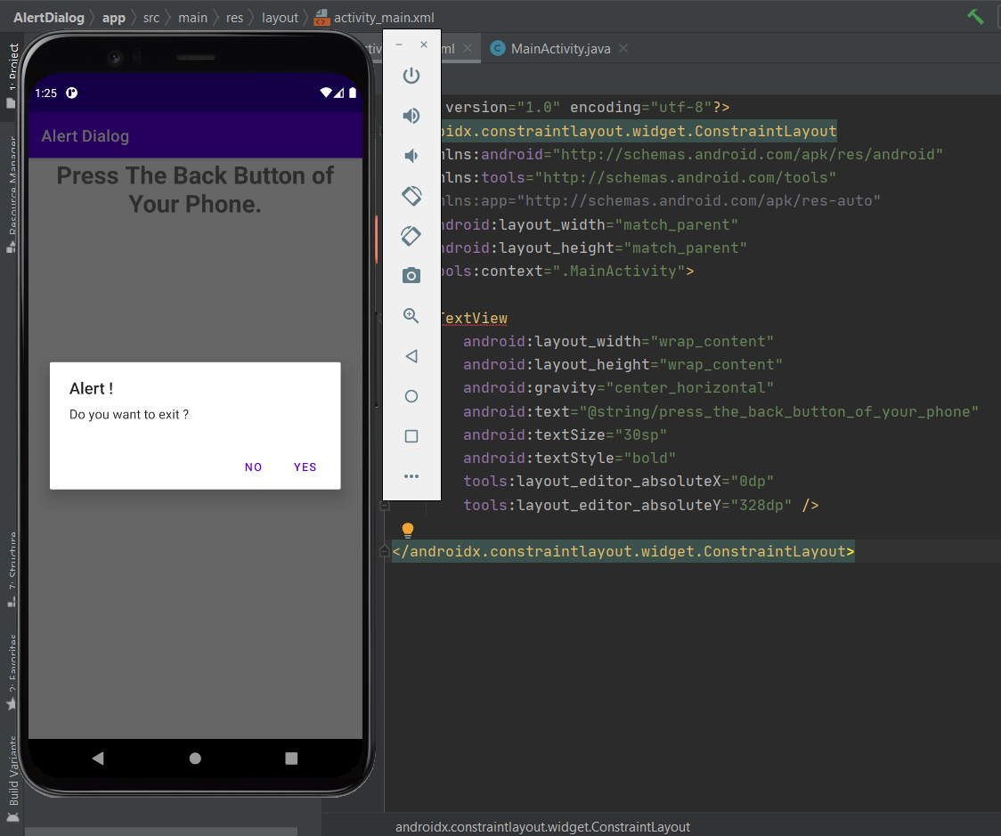

1. **Implement Grid view project.**

**MainActivity.java**

package com.example.gridview;

import androidx.appcompat.app.AppCompatActivity;

import android.os.Bundle;

import android.widget.GridView;

import java.util.ArrayList;

public class MainActivity extends AppCompatActivity {

GridView coursesGV;

@Override

protected void onCreate(Bundle savedInstanceState) {

super.onCreate(savedInstanceState);

setContentView(R.layout.activity_main);

coursesGV = findViewById(R.id.idGVcourses);

ArrayList<CourseModel> courseModelArrayList = new ArrayList<CourseModel>();

courseModelArrayList.add(new CourseModel("DSA", R.drawable.ic_gfglogo));

courseModelArrayList.add(new CourseModel("JAVA", R.drawable.ic_gfglogo));

courseModelArrayList.add(new CourseModel("C++", R.drawable.ic_gfglogo));

courseModelArrayList.add(new CourseModel("Python", R.drawable.ic_gfglogo));

courseModelArrayList.add(new CourseModel("Javascript", R.drawable.ic_gfglogo));

courseModelArrayList.add(new CourseModel("DSA", R.drawable.ic_gfglogo));

CourseGVAdapter adapter = new CourseGVAdapter(this, courseModelArrayList);

coursesGV.setAdapter(adapter);

}

}

**CourseModel.java**

package com.example.gridview;

public class CourseModel {

private String course_name;

private int imgid;

public CourseModel(String course_name, int imgid) {

this.course_name = course_name;

this.imgid = imgid;

}

public String getCourse_name() {

return course_name;

}

public void setCourse_name(String course_name) {

this.course_name = course_name;

}

public int getImgid() {

return imgid;

}

public void setImgid(int imgid) {

this.imgid = imgid;

}

}

**CourseGVAdapter.java**

package com.example.gridview;

import android.content.Context;

import android.view.LayoutInflater;

import android.view.View;

import android.view.ViewGroup;

import android.widget.ArrayAdapter;

import android.widget.ImageView;

import android.widget.TextView;

import androidx.annotation.NonNull;

import androidx.annotation.Nullable;

import java.util.ArrayList;

public class CourseGVAdapter extends ArrayAdapter<CourseModel> {

public CourseGVAdapter(@NonNull Context context, ArrayList<CourseModel> courseModelArrayList) {

super(context, 0, courseModelArrayList);

}

@NonNull

@Override

public View getView(int position, @Nullable View convertView, @NonNull ViewGroup parent) {

View listitemView = convertView;

if (listitemView == null) {

// Layout Inflater inflates each item to be displayed in GridView.

listitemView = LayoutInflater.from(getContext()).inflate(R.layout.card_item, parent, false);

}

CourseModel courseModel = getItem(position);

TextView courseTV = listitemView.findViewById(R.id.idTVCourse);

ImageView courseIV = listitemView.findViewById(R.id.idIVcourse);

courseTV.setText(courseModel.getCourse_name());

courseIV.setImageResource(courseModel.getImgid());

return listitemView;

}

}

**Card_item.xml**

<?xml version="1.0" encoding="utf-8"?>

<androidx.constraintlayout.widget.ConstraintLayout

xmlns:android="http://schemas.android.com/apk/res/android"

xmlns:app="http://schemas.android.com/apk/res-auto"

android:layout_width="match_parent"

android:layout_height="120dp"

android:layout_gravity="center"

android:layout_margin="5dp"

app:cardCornerRadius="5dp"

app:cardElevation="5dp">

<LinearLayout

android:layout_width="match_parent"

android:layout_height="wrap_content"

android:orientation="vertical">

<ImageView

android:id="@+id/idIVcourse"

android:layout_width="100dp"

android:layout_height="100dp"

android:layout_gravity="center"

android:src="@mipmap/ic_launcher" />

<TextView

android:id="@+id/idTVCourse"

android:layout_width="match_parent"

android:layout_height="wrap_content"

android:text="@string/app_name"

android:textAlignment="center" />

</LinearLayout>

</androidx.constraintlayout.widget.ConstraintLayout>

**Activity_main.xml**

<?xml version="1.0" encoding="utf-8"?>

<androidx.constraintlayout.widget.ConstraintLayout

xmlns:android="http://schemas.android.com/apk/res/android"

xmlns:tools="http://schemas.android.com/tools"

android:layout_width="match_parent"

android:layout_height="match_parent"

tools:context=".MainActivity">

<GridView

android:id="@+id/idGVcourses"

android:layout_width="match_parent"

android:layout_height="match_parent"

android:horizontalSpacing="6dp"

android:numColumns="2"

android:verticalSpacing="6dp" />

</androidx.constraintlayout.widget.ConstraintLayout>

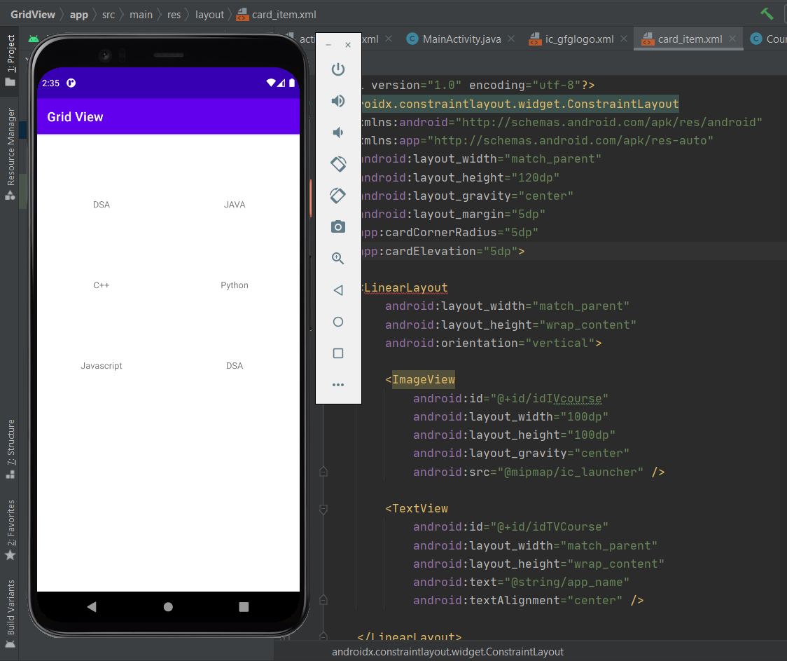

1. **Implement List view project.**

**MainActivity.java**

package com.example.listview;

import androidx.appcompat.app.AppCompatActivity;

import android.os.Bundle;

import android.widget.ArrayAdapter;

import android.widget.ListView;

public class MainActivity extends AppCompatActivity {

ListView l;

String tutorials[]

= { "Algorithms", "Data Structures",

"Languages", "Interview Corner",

"GATE", "ISRO CS",

"UGC NET CS", "CS Subjects",

"Web Technologies" };

@Override

protected void onCreate(Bundle savedInstanceState) {

super.onCreate(savedInstanceState);

setContentView(R.layout.activity_main);

l = findViewById(R.id.list);

ArrayAdapter<String> arr;

arr = new ArrayAdapter<String>(this, R.layout.support_simple_spinner_dropdown_item, tutorials);

l.setAdapter(arr);

}

}

**Activity_main.xml**

<?xml version="1.0" encoding="utf-8"?>

<LinearLayout

xmlns:android="http://schemas.android.com/apk/res/android"

xmlns:app="http://schemas.android.com/apk/res-auto"

xmlns:tools="http://schemas.android.com/tools"

android:layout_width="match_parent"

android:layout_height="match_parent"

tools:context=".MainActivity">

<ListView

android:id="@+id/list"

android:layout_width="match_parent"

android:layout_height="match_parent"/>

</LinearLayout>

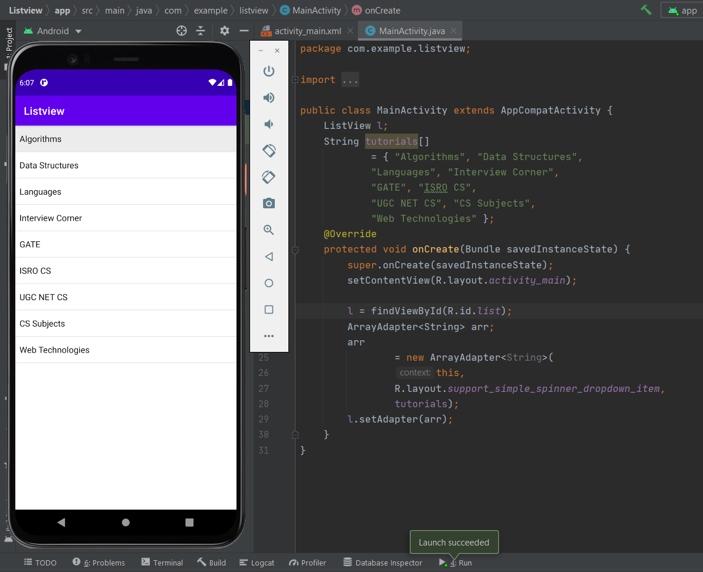

1. **Implement todo list project.**

**Activity_main.xml**

<?xml version="1.0" encoding="utf-8"?>

<LinearLayout xmlns:android="http://schemas.android.com/apk/res/android"

xmlns:app="http://schemas.android.com/apk/res-auto"

xmlns:tools="http://schemas.android.com/tools"

android:layout_width="match_parent"

android:layout_height="match_parent"

android:background="@android:color/holo_blue_bright"

android:orientation="vertical"

tools:context=".MainActivity">

<LinearLayout

android:layout_width="match_parent"

android:layout_height="wrap_content"

android:layout_margin="5dp"

android:orientation="horizontal">

<EditText

android:id="@+id/editText"

android:layout_width="wrap_content"

android:layout_height="wrap_content"

android:layout_weight="4"

android:ems="10"

android:hint=" Add new item"

android:inputType="textPersonName" />

<Button

android:id="@+id/button"

android:layout_width="wrap_content"

android:layout_height="wrap_content"

android:layout_weight="1"

android:text="Add" />

</LinearLayout>

<ListView

android:id="@+id/list"

android:layout_width="match_parent"

android:layout_height="match_parent" />

</LinearLayout>

**MainActivity.java**

package com.example.todolist;

import androidx.appcompat.app.AppCompatActivity;

import android.os.Bundle;

import android.view.View;

import android.widget.ArrayAdapter;

import android.widget.Button;

import android.widget.EditText;

import android.widget.ListView;

import java.util.ArrayList;

public class MainActivity extends AppCompatActivity {

EditText item;

Button add;

ListView listView;

ArrayList<String> itemList = new ArrayList<>();

ArrayAdapter<String> arrayAdapter;

@Override

protected void onCreate(Bundle savedInstanceState) {

super.onCreate(savedInstanceState);

setContentView(R.layout.activity_main);

item = findViewById(R.id.editText);

add = findViewById(R.id.button);

listView = findViewById(R.id.list);

itemList=FileHelper.readData(this);

arrayAdapter = new ArrayAdapter<>(this, android.R.layout.simple_list_item_1,

android.R.id.text1,itemList);

listView.setAdapter(arrayAdapter);

add.setOnClickListener(new View.OnClickListener() {

@Override

public void onClick(View view) {

String itemName = item.getText().toString();

itemList.add(itemName);

item.setText("");

FileHelper.writeData(itemList,getApplicationContext());

arrayAdapter.notifyDataSetChanged();

}

});

}

}

**FileHelper.java**

package com.example.todolist;

import android.content.Context;

import java.io.FileInputStream;

import java.io.FileNotFoundException;

import java.io.FileOutputStream;

import java.io.IOException;

import java.io.ObjectInputStream;

import java.io.ObjectOutputStream;

import java.util.ArrayList;

public class FileHelper {

public static final String FILENAME = "listinfo.dat";

public static void writeData(ArrayList<String> item, Context context)

{

try {

FileOutputStream fos = context.openFileOutput(FILENAME,Context.MODE_PRIVATE);

ObjectOutputStream oas = new ObjectOutputStream(fos);

oas.writeObject(item);

oas.close();

} catch (FileNotFoundException e) {

e.printStackTrace();

} catch (IOException e) {

e.printStackTrace();

}

}

public static ArrayList<String> readData(Context context)

{

ArrayList<String> itemList = null;

try {

FileInputStream fis = context.openFileInput(FILENAME);

ObjectInputStream ois = new ObjectInputStream(fis);

itemList = (ArrayList<String>) ois.readObject();

} catch (FileNotFoundException e) {

itemList = new ArrayList<>();

e.printStackTrace();

} catch (IOException e) {

e.printStackTrace();

} catch (ClassNotFoundException e) {

e.printStackTrace();

}

return itemList;

}

}

1. **Implement Recycler view project.**

**Activity_main.xml**

<?xml version="1.0" encoding="utf-8"?>

<android.support.v7.widget.RecyclerView

xmlns:android="http://schemas.android.com/apk/res/android"

xmlns:tools="http://schemas.android.com/tools"

android:layout_width="match_parent"

android:layout_height="match_parent"

android:scrollbars="vertical"

android:id="@+id/recyclerView"

tools:context="example.javatpoint.com.recyclerviewlist.MainActivity">

</android.support.v7.widget.RecyclerView>

**MainActivity.java**

package com.example.recyclerview;

import androidx.appcompat.app.AppCompatActivity;

import androidx.recyclerview.widget.LinearLayoutManager;

import androidx.recyclerview.widget.RecyclerView;

import android.os.Bundle;

public class MainActivity extends AppCompatActivity {

@Override

protected void onCreate(Bundle savedInstanceState) {

super.onCreate(savedInstanceState);

setContentView(R.layout.activity_main);

MyListData[] myListData = new MyListData[] {

new MyListData("Email", android.R.drawable.ic_dialog_email),

new MyListData("Info", android.R.drawable.ic_dialog_info),

new MyListData("Delete", android.R.drawable.ic_delete),

new MyListData("Dialer", android.R.drawable.ic_dialog_dialer),

new MyListData("Alert", android.R.drawable.ic_dialog_alert),

new MyListData("Map", android.R.drawable.ic_dialog_map),

new MyListData("Email", android.R.drawable.ic_dialog_email),

new MyListData("Info", android.R.drawable.ic_dialog_info),

new MyListData("Delete", android.R.drawable.ic_delete),

new MyListData("Dialer", android.R.drawable.ic_dialog_dialer),

new MyListData("Alert", android.R.drawable.ic_dialog_alert),

new MyListData("Map", android.R.drawable.ic_dialog_map),

};

RecyclerView recyclerView = (RecyclerView) findViewById(R.id.recyclerView);

MyListAdapter adapter = new MyListAdapter(myListData);

recyclerView.setHasFixedSize(true);

recyclerView.setLayoutManager(new LinearLayoutManager(this));

recyclerView.setAdapter(adapter);

}

}

**MyListAdapter.java**

package com.example.recyclerview;

import android.view.LayoutInflater;

import android.view.View;

import android.view.ViewGroup;

import android.widget.ImageView;

import android.widget.RelativeLayout;

import android.widget.TextView;

import android.widget.Toast;

import androidx.recyclerview.widget.RecyclerView;

public class MyListAdapter extends RecyclerView.Adapter<MyListAdapter.ViewHolder>

{

private MyListData[] listdata;

// RecyclerView recyclerView;

public MyListAdapter(MyListData[] listdata) {

this.listdata = listdata;

}

@Override

public ViewHolder onCreateViewHolder(ViewGroup parent, int viewType) {

LayoutInflater layoutInflater = LayoutInflater.from(parent.getContext());

View listItem= layoutInflater.inflate(R.layout.list_item, parent, false);

ViewHolder viewHolder = new ViewHolder(listItem);

return viewHolder;

}

@Override

public void onBindViewHolder(ViewHolder holder, int position) {

final MyListData myListData = listdata[position];

holder.textView.setText(listdata[position].getDescription());

holder.imageView.setImageResource(listdata[position].getImgId());

holder.relativeLayout.setOnClickListener(new View.OnClickListener() {

@Override

public void onClick(View view) {

Toast.makeText(view.getContext(),"click on item: "+myListData.getDescription(),Toast.LENGTH_LONG).show();

}

});

}

@Override

public int getItemCount() {

return listdata.length;

}

public static class ViewHolder extends RecyclerView.ViewHolder {

public ImageView imageView;

public TextView textView;

public RelativeLayout relativeLayout;

public ViewHolder(View itemView) {

super(itemView);

this.imageView = (ImageView) itemView.findViewById(R.id.imageView);

this.textView = (TextView) itemView.findViewById(R.id.textView);

relativeLayout = (RelativeLayout)itemView.findViewById(R.id.relativeLayout);

}

}

}

**List_item.xml**

<?xml version="1.0" encoding="utf-8"?>

<RelativeLayout xmlns:android="http://schemas.android.com/apk/res/android"

android:id="@+id/relativeLayout"

android:layout_width="match_parent"

android:layout_height="?android:attr/listPreferredItemHeightLarge"

android:background="@drawable/border">

<ImageView

android:id="@+id/imageView"

android:layout_width="wrap_content"

android:layout_height="wrap_content"

android:layout_centerVertical="true"

android:layout_alignParentStart="true"

android:layout_alignParentLeft="true"

android:layout_marginStart="@dimen/activity_horizontal_margin"

android:layout_marginEnd="@dimen/activity_horizontal_margin"

android:contentDescription="Icon" />

<TextView

android:id="@+id/textView"

android:layout_width="wrap_content"

android:layout_height="match_parent"

android:layout_toEndOf="@id/imageView"

android:layout_toRightOf="@id/imageView"

android:gravity="center_vertical"

android:textSize="16sp"/>

</RelativeLayout>

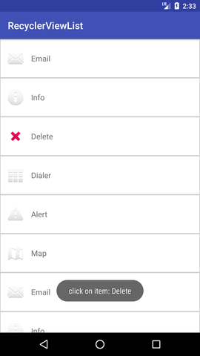

1. **Implement Scroll view project.**

**Activity_main.xml**

<?xml version="1.0" encoding="utf-8"?>

<RelativeLayout xmlns:android="http://schemas.android.com/apk/res/android"

xmlns:tools="http://schemas.android.com/tools"

android:layout_width="match_parent"

android:layout_height="match_parent"

android:paddingBottom="@dimen/activity_vertical_margin"

android:paddingLeft="@dimen/activity_horizontal_margin"

android:paddingRight="@dimen/activity_horizontal_margin"

android:paddingTop="@dimen/activity_vertical_margin"

tools:context="com.example.test.scrollviews.MainActivity">

<TextView

android:layout_width="wrap_content"

android:layout_height="wrap_content"

android:textAppearance="?android:attr/textAppearanceMedium"

android:text="Vertical ScrollView example"

android:id="@+id/textView"

android:layout_gravity="center_horizontal"

android:layout_centerHorizontal="true"

android:layout_alignParentTop="true" />

<ScrollView android:layout_marginTop="30dp"

android:layout_width="fill_parent"

android:layout_height="wrap_content"

android:id="@+id/scrollView">

<LinearLayout

android:layout_width="fill_parent"

android:layout_height="fill_parent"

android:orientation="vertical" >

<Button

android:layout_width="fill_parent"

android:layout_height="wrap_content"

android:text="Button 1" />

<Button

android:layout_width="fill_parent"

android:layout_height="wrap_content"

android:text="Button 2" />

<Button

android:layout_width="fill_parent"

android:layout_height="wrap_content"

android:text="Button 3" />

<Button

android:layout_width="fill_parent"

android:layout_height="wrap_content"

android:text="Button 4" />

<Button

android:layout_width="fill_parent"

android:layout_height="wrap_content"

android:text="Button 5" />

<Button

android:layout_width="fill_parent"

android:layout_height="wrap_content"

android:text="Button 6" />

<Button

android:layout_width="fill_parent"

android:layout_height="wrap_content"

android:text="Button 7" />

<Button

android:layout_width="fill_parent"

android:layout_height="wrap_content"

android:text="Button 8" />

<Button

android:layout_width="fill_parent"

android:layout_height="wrap_content"

android:text="Button 9" />

<Button

android:layout_width="fill_parent"

android:layout_height="wrap_content"

android:text="Button 10" />

<Button

android:layout_width="fill_parent"

android:layout_height="wrap_content"

android:text="Button 11" />

<Button

android:layout_width="fill_parent"

android:layout_height="wrap_content"

android:text="Button 12" />

<Button

android:layout_width="fill_parent"

android:layout_height="wrap_content"

android:text="Button 13" />

<Button

android:layout_width="fill_parent"

android:layout_height="wrap_content"

android:text="Button 14" />

<Button

android:layout_width="fill_parent"

android:layout_height="wrap_content"

android:text="Button 15" />

<Button

android:layout_width="fill_parent"

android:layout_height="wrap_content"

android:text="Button 16" />

<Button

android:layout_width="fill_parent"

android:layout_height="wrap_content"

android:text="Button 17" />

<Button

android:layout_width="fill_parent"

android:layout_height="wrap_content"

android:text="Button 18" />

<Button

android:layout_width="fill_parent"

android:layout_height="wrap_content"

android:text="Button 19" />

<Button

android:layout_width="fill_parent"

android:layout_height="wrap_content"

android:text="Button 20" />

</LinearLayout>

</ScrollView>

</RelativeLayout>

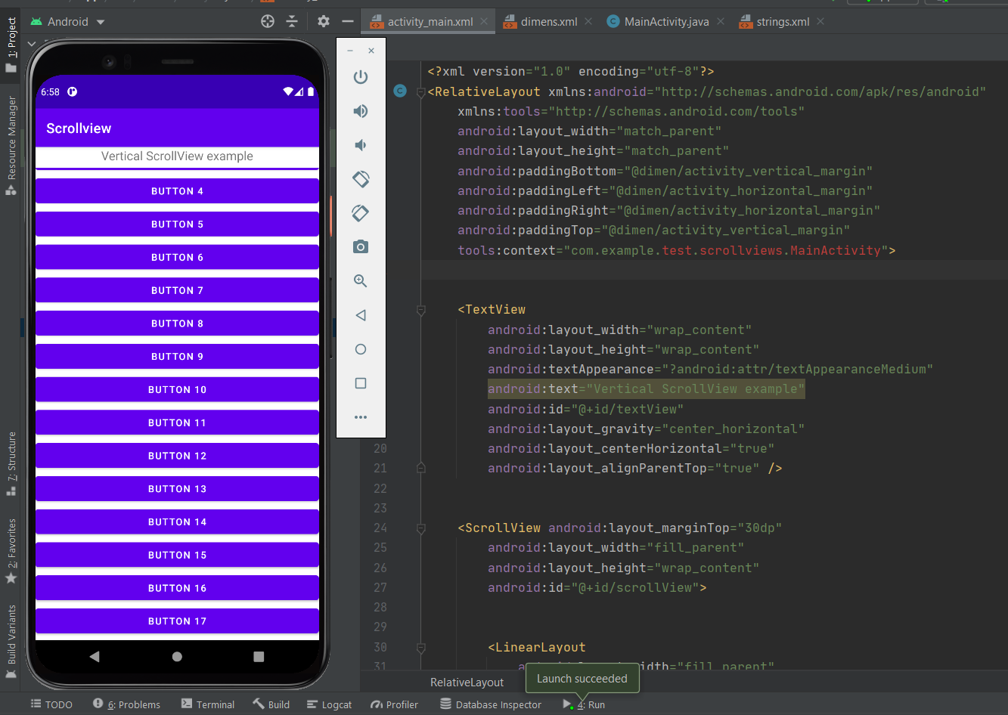

1. **Implement Send Email Functionality.**

**Activity_main.xml**

<?xml version="1.0" encoding="utf-8"?>

<androidx.constraintlayout.widget.ConstraintLayout xmlns:android="http://schemas.android.com/apk/res/android"

xmlns:app="http://schemas.android.com/apk/res-auto"

xmlns:tools="http://schemas.android.com/tools"

android:layout_width="match_parent"

android:layout_height="match_parent"

tools:context=".MainActivity">

<EditText

android:id="@+id/EmailAddress"

android:layout_width="wrap_content"

android:layout_height="wrap_content"

android:ems="10"

android:hint="Enter Email Address"

android:inputType="textEmailAddress"

app:layout_constraintBottom_toTopOf="@+id/EmailSubject"

app:layout_constraintEnd_toEndOf="parent"

app:layout_constraintHorizontal_bias="0.5"

app:layout_constraintStart_toStartOf="parent"

app:layout_constraintTop_toTopOf="parent" />

<EditText

android:id="@+id/EmailSubject"

android:layout_width="wrap_content"

android:layout_height="wrap_content"

android:ems="10"

android:hint="Enter Email Subject"

android:inputType="textShortMessage|textEmailAddress"

app:layout_constraintBottom_toTopOf="@+id/EmailMessage"

app:layout_constraintEnd_toEndOf="parent"

app:layout_constraintHorizontal_bias="0.5"

app:layout_constraintStart_toStartOf="parent"

app:layout_constraintTop_toBottomOf="@+id/EmailAddress" />

<EditText

android:id="@+id/EmailMessage"

android:layout_width="wrap_content"

android:layout_height="150dp"

android:ems="10"

android:hint="Enter Your Message"

android:inputType="textMultiLine|textEmailAddress"

app:layout_constraintBottom_toTopOf="@+id/buttonsendemail"

app:layout_constraintEnd_toEndOf="parent"

app:layout_constraintHorizontal_bias="0.5"

app:layout_constraintStart_toStartOf="parent"

app:layout_constraintTop_toBottomOf="@+id/EmailSubject" />

<Button

android:id="@+id/buttonsendemail"

android:layout_width="wrap_content"

android:layout_height="wrap_content"

android:text="SEND EMAIL"

app:layout_constraintBottom_toBottomOf="parent"

app:layout_constraintEnd_toEndOf="parent"

app:layout_constraintHorizontal_bias="0.5"

app:layout_constraintStart_toStartOf="parent"

app:layout_constraintTop_toBottomOf="@+id/EmailMessage" />

</androidx.constraintlayout.widget.ConstraintLayout>

**MainActivity.java**

package com.company.sendemail;

import androidx.appcompat.app.AppCompatActivity;

import android.content.Intent;

import android.net.Uri;

import android.os.Bundle;

import android.view.View;

import android.widget.Button;

import android.widget.EditText;

public class MainActivity extends AppCompatActivity {

Button send;

EditText address,message,subject;

@Override

protected void onCreate(Bundle savedInstanceState) {

super.onCreate(savedInstanceState);

setContentView(R.layout.activity_main);

address=findViewById(R.id.EmailAddress);

message=findViewById(R.id.EmailMessage);

subject=findViewById(R.id.EmailSubject);

send=findViewById(R.id.buttonsendemail);

send.setOnClickListener(new View.OnClickListener() {

@Override

public void onClick(View view) {

String userAddress=address.getText().toString();//text to string

String userMessage=message.getText().toString();

String userSubject=subject.getText().toString();

sendEmail(userAddress,userSubject,userMessage);//onclick event

}

});

}

public void sendEmail(String userAddress,String userSubject,String userMessage)//mail sending method

{

String[] emailAddress = {userAddress}; //email address store in array

Intent emailIntent = new Intent(Intent.ACTION_SEND);//sending mail, it switch one activity to another activity

emailIntent.setData(Uri.parse("mailto:"));//send data as a email

emailIntent.setType("text/plain");

emailIntent.putExtra(Intent.EXTRA_EMAIL,emailAddress);//data will send into mail address section

emailIntent.putExtra(Intent.EXTRA_SUBJECT,userSubject);//data will send into subject section

emailIntent.putExtra(Intent.EXTRA_TEXT,userMessage);//data will send into user message section

startActivity(Intent.createChooser(emailIntent,"email send"));//user choice

}

}

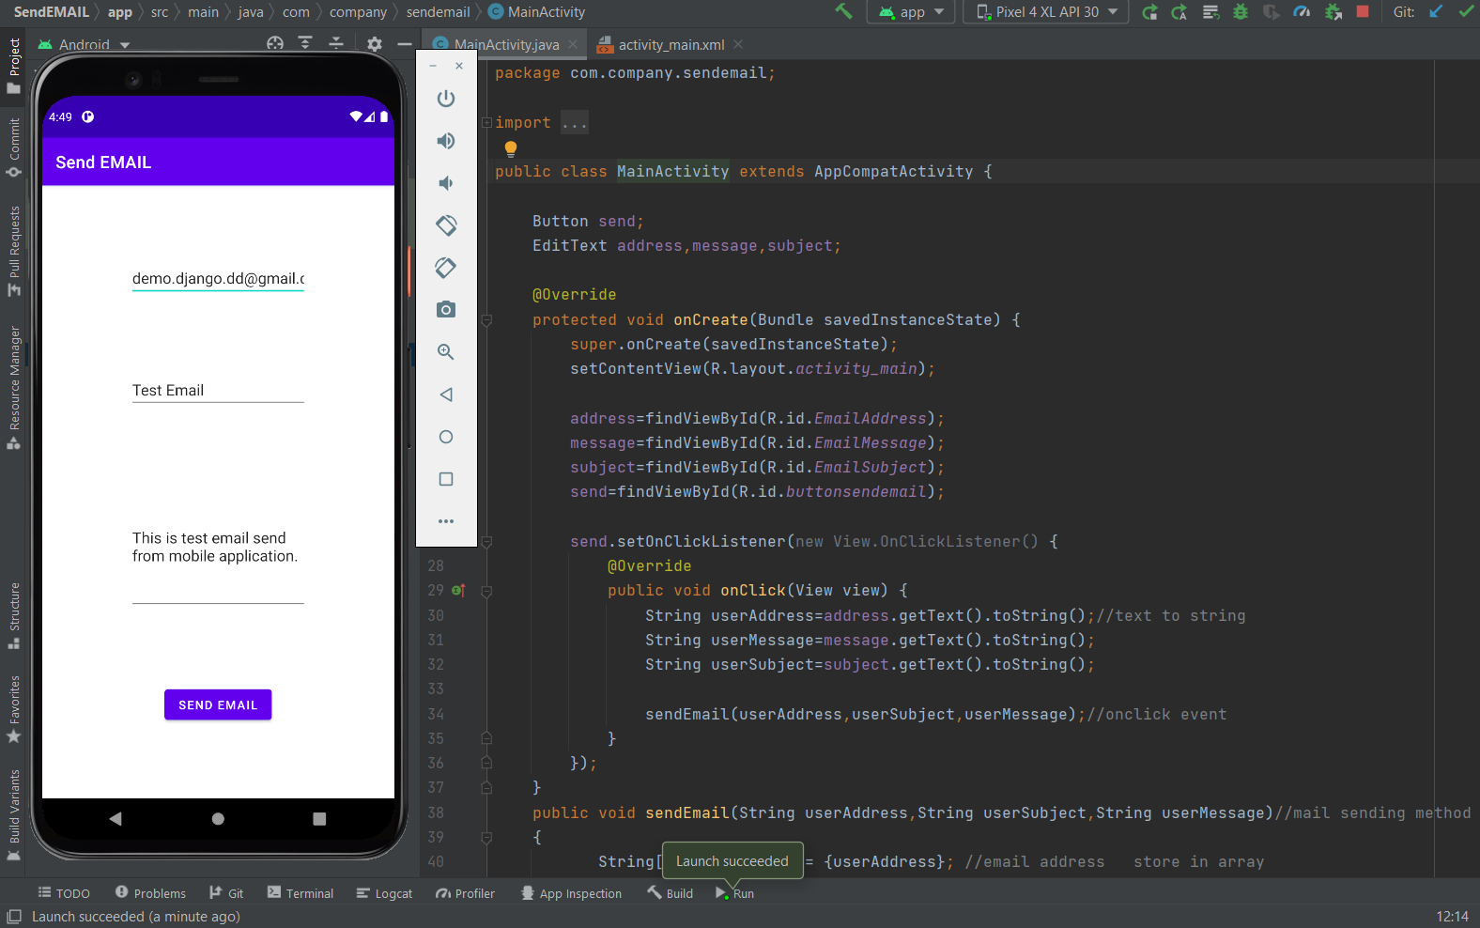

1. **Implement Send SMS Functionality.**

**Activity_main.xml**

<?xml version="1.0" encoding="utf-8"?>

<androidx.constraintlayout.widget.ConstraintLayout xmlns:android="http://schemas.android.com/apk/res/android"

xmlns:app="http://schemas.android.com/apk/res-auto"

xmlns:tools="http://schemas.android.com/tools"

android:layout_width="match_parent"

android:layout_height="match_parent"

tools:context=".MainActivity">

<Button

android:id="@+id/buttonSend"

android:layout_width="wrap_content"

android:layout_height="wrap_content"

android:layout_marginStart="72dp"

android:layout_marginLeft="72dp"

android:layout_marginBottom="135dp"

android:text="Send SMS"

app:layout_constraintBottom_toBottomOf="parent"

app:layout_constraintEnd_toEndOf="parent"

app:layout_constraintHorizontal_bias="0.34"

app:layout_constraintStart_toStartOf="parent"

app:layout_constraintTop_toBottomOf="@+id/editTextNumber" />

<EditText

android:id="@+id/editTextMessage"

android:layout_width="300dp"

android:layout_height="0dp"

android:layout_marginTop="79dp"

android:layout_marginBottom="87dp"

android:ems="10"

android:gravity="start|top"

android:inputType="textMultiLine"

app:layout_constraintBottom_toTopOf="@+id/editTextNumber"

app:layout_constraintEnd_toEndOf="parent"

app:layout_constraintHorizontal_bias="0.5"

app:layout_constraintStart_toStartOf="parent"

app:layout_constraintTop_toTopOf="parent" />

<EditText

android:id="@+id/editTextNumber"

android:layout_width="0dp"

android:layout_height="wrap_content"

android:layout_marginStart="46dp"

android:layout_marginLeft="46dp"

android:layout_marginEnd="46dp"

android:layout_marginRight="46dp"

android:layout_marginBottom="59dp"

android:ems="10"

android:inputType="phone"

app:layout_constraintBottom_toTopOf="@+id/buttonSend"

app:layout_constraintEnd_toEndOf="parent"

app:layout_constraintHorizontal_bias="1.0"

app:layout_constraintStart_toStartOf="parent"

app:layout_constraintTop_toBottomOf="@+id/editTextMessage" />

</androidx.constraintlayout.widget.ConstraintLayout>

**MainActivity.java**

package com.company.sendsms;

import …

public class MainActivity extends AppCompatActivity {

Button send;

EditText message,number;

String userMessage;

String userNumber;

@Override

protected void onCreate(Bundle savedInstanceState) {

super.onCreate(savedInstanceState);

setContentView(R.layout.activity_main);

send=findViewById(R.id.buttonSend);

message=findViewById(R.id.editTextMessage);

number=findViewById(R.id.editTextNumber);

send.setOnClickListener(new View.OnClickListener() {

@Override

public void onClick(View view) {

userMessage = message.getText().toString();

userNumber = number.getText().toString();

sendSMS(userMessage,userNumber);

}

});

}

public void sendSMS(String userMessage,String userNumber)

{

if(ContextCompat.checkSelfPermission(this

, Manifest.permission.SEND_SMS)!= PackageManager.PERMISSION_GRANTED)//permission

{

ActivityCompat.requestPermissions(this,new String[]{Manifest.permission.SEND_SMS},1);

}

else

{

SmsManager smsManager = SmsManager.getDefault();

smsManager.sendTextMessage(userNumber,null,userMessage,null,null);

}

}

@Override

public void onRequestPermissionsResult(int requestCode, @NonNull String[] permissions, @NonNull int[] grantResults) {

super.onRequestPermissionsResult(requestCode, permissions, grantResults);

if(requestCode==1 && grantResults.length > 0 && grantResults[0]== PackageManager.PERMISSION_GRANTED)

{

SmsManager smsManager = SmsManager.getDefault();

smsManager.sendTextMessage(userNumber,null,userMessage,null,null);

}

}

}

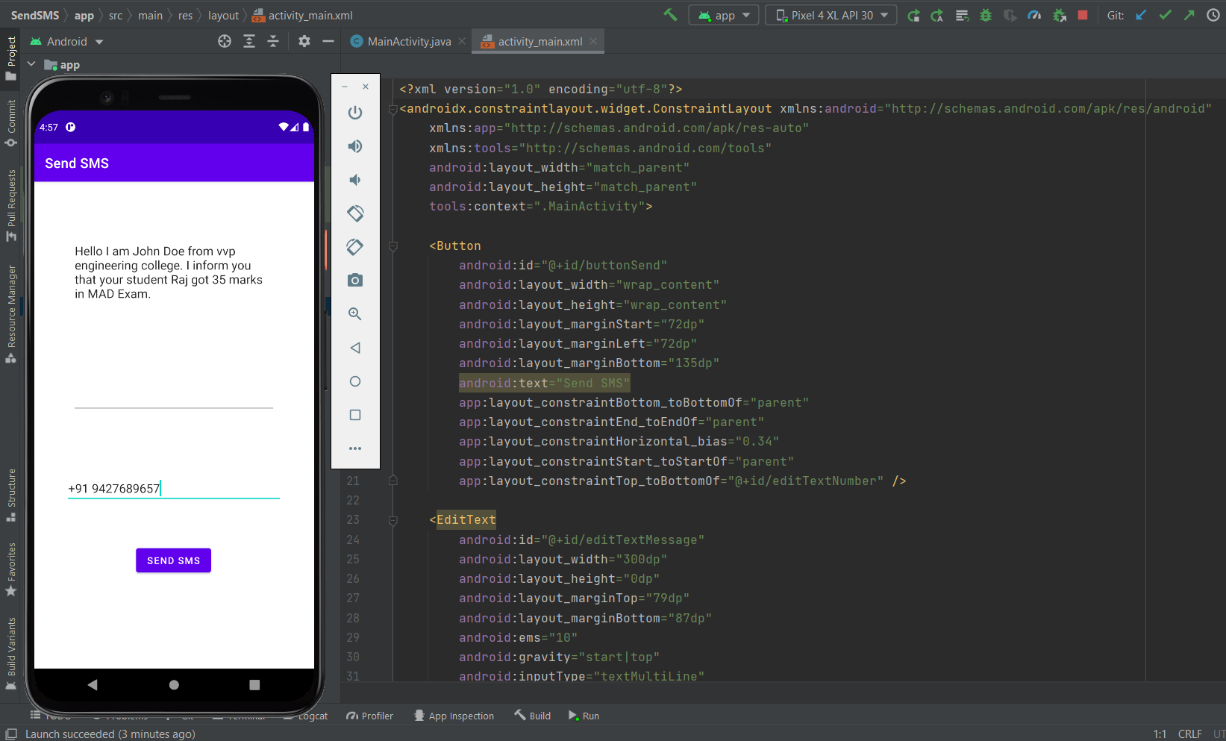

1. **Implement Shared preferences project.**

**Activity_main.xml**

<?xml version="1.0" encoding="utf-8"?>

<RelativeLayout

xmlns:android="http://schemas.android.com/apk/res/android"

xmlns:tools="http://schemas.android.com/tools"

android:layout_width="match_parent"

android:layout_height="match_parent"

tools:context=".MainActivity"

tools:ignore="HardcodedText">

<TextView

android:id="@+id/textview"

android:layout_width="wrap_content"

android:layout_height="wrap_content"

android:layout_centerHorizontal="true"

android:layout_marginTop="32dp"

android:text="Shared Preferences Demo"

android:textColor="@android:color/black"

android:textSize="24sp" />

<EditText

android:id="@+id/edit1"

android:layout_width="match_parent"

android:layout_height="wrap_content"

android:layout_below="@+id/textview"

android:layout_marginStart="16dp"

android:layout_marginTop="8dp"

android:layout_marginEnd="16dp"

android:hint="Enter your Name"

android:padding="10dp" />

<EditText

android:id="@+id/edit2"

android:layout_width="match_parent"

android:layout_height="wrap_content"

android:layout_below="@+id/edit1"

android:layout_marginStart="16dp"

android:layout_marginTop="8dp"

android:layout_marginEnd="16dp"

android:hint="Enter your Age"

android:padding="10dp" />

</RelativeLayout>

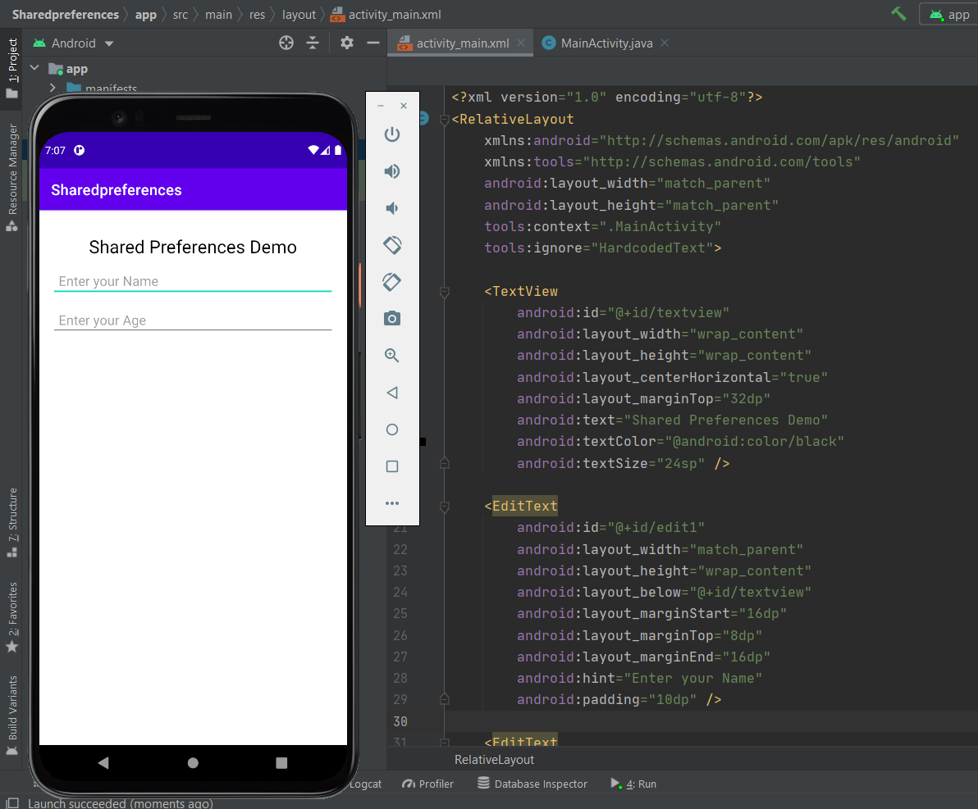

1. **Implement Firebase used project.**

**Activity_main.xml**

<?xml version="1.0" encoding="utf-8"?>

<androidx.constraintlayout.widget.ConstraintLayout xmlns:android="http://schemas.android.com/apk/res/android"

xmlns:app="http://schemas.android.com/apk/res-auto"

xmlns:tools="http://schemas.android.com/tools"

android:id="@+id/Signup_buttton"

android:layout_width="match_parent"

android:layout_height="match_parent"

tools:context=".MainActivity">

<Button

android:id="@+id/signupbutton"

android:layout_width="wrap_content"

android:layout_height="wrap_content"

android:layout_marginStart="133dp"

android:layout_marginBottom="156dp"

android:text="Sign UP"

app:layout_constraintBottom_toBottomOf="parent"

app:layout_constraintEnd_toEndOf="parent"

app:layout_constraintHorizontal_bias="0.173"

app:layout_constraintStart_toStartOf="parent" />

<EditText

android:id="@+id/editTextTextEmaill"

android:layout_width="wrap_content"

android:layout_height="wrap_content"

android:layout_marginStart="3dp"

android:layout_marginBottom="48dp"

android:ems="10"

android:hint="Please Enter Your Email Address"

android:inputType="textEmailAddress"

app:layout_constraintBottom_toTopOf="@+id/editTextPassword"

app:layout_constraintEnd_toEndOf="parent"

app:layout_constraintHorizontal_bias="0.5"

app:layout_constraintStart_toStartOf="parent" />

<EditText

android:id="@+id/editTextPassword"

android:layout_width="wrap_content"

android:layout_height="wrap_content"

android:layout_marginStart="70dp"

android:layout_marginBottom="44dp"

android:ems="10"

android:hint="Please Enter Your Password"

android:inputType="textPassword"

app:layout_constraintBottom_toTopOf="@+id/Sign_inButtton"

app:layout_constraintEnd_toEndOf="parent"

app:layout_constraintHorizontal_bias="0.229"

app:layout_constraintStart_toStartOf="parent" />

<Button

android:id="@+id/Sign_inButtton"

android:layout_width="wrap_content"

android:layout_height="wrap_content"

android:layout_marginStart="8dp"

android:layout_marginBottom="116dp"

android:text="Sign in"

app:layout_constraintBottom_toTopOf="@+id/signupbutton"

app:layout_constraintEnd_toEndOf="parent"

app:layout_constraintHorizontal_bias="0.5"

app:layout_constraintStart_toStartOf="parent" />

<Button

android:id="@+id/ForgetButton"

android:layout_width="wrap_content"

android:layout_height="wrap_content"

android:layout_marginStart="9dp"

android:layout_marginTop="44dp"

android:text="Forget Password"

app:layout_constraintEnd_toEndOf="parent"

app:layout_constraintHorizontal_bias="0.542"

app:layout_constraintStart_toStartOf="parent"

app:layout_constraintTop_toBottomOf="@+id/signupbutton" />

<Button

android:id="@+id/buttonPhoneSign"

android:layout_width="wrap_content"

android:layout_height="wrap_content"

android:layout_marginTop="32dp"

android:text="Sign in With Phone no"

app:layout_constraintEnd_toEndOf="parent"

app:layout_constraintHorizontal_bias="0.5"

app:layout_constraintStart_toStartOf="parent"

app:layout_constraintTop_toBottomOf="@+id/Sign_inButtton" />

</androidx.constraintlayout.widget.ConstraintLayout>

**MainActivity.java**

package com.company.firebaseexample;

import androidx.annotation.NonNull;

import androidx.appcompat.app.AppCompatActivity;

import android.Manifest;

import android.content.Intent;

import android.os.Bundle;

import android.view.View;

import android.widget.Button;

import android.widget.EditText;

import android.widget.TextView;

import android.widget.Toast;

import com.google.android.gms.tasks.OnCompleteListener;

import com.google.android.gms.tasks.Task;

import com.google.firebase.auth.AuthResult;

import com.google.firebase.auth.FirebaseAuth;

import com.google.firebase.auth.FirebaseUser;

import com.google.firebase.database.DataSnapshot;

import com.google.firebase.database.DatabaseError;

import com.google.firebase.database.DatabaseReference;

import com.google.firebase.database.FirebaseDatabase;

import com.google.firebase.database.ValueEventListener;

public class MainActivity extends AppCompatActivity {

EditText mail;

EditText password;

Button signin;

Button signup;

Button forgotpassword;

Button phoneSign;

FirebaseAuth auth = FirebaseAuth.getInstance();

@Override

protected void onCreate(Bundle savedInstanceState) {

super.onCreate(savedInstanceState);

setContentView(R.layout.activity_main);

mail=findViewById(R.id.editTextTextEmaill);

password=findViewById(R.id.editTextPassword);

signin=findViewById(R.id.Sign_inButtton);

signup=findViewById(R.id.signupbutton);

forgotpassword=findViewById(R.id.ForgetButton);

phoneSign=findViewById(R.id.buttonPhoneSign);

phoneSign.setOnClickListener(new View.OnClickListener() {

@Override

public void onClick(View view) {

Intent i = new Intent(MainActivity.this,phoneSignActivity.class);

startActivity(i);

finish();

}

});

signin.setOnClickListener(new View.OnClickListener() {

@Override

public void onClick(View view) {

String userMail = mail.getText().toString();

String userPassword = password.getText().toString();

signFirebase(userMail,userPassword);

}

});

signup.setOnClickListener(new View.OnClickListener() {

@Override

public void onClick(View view) {

Intent i = new Intent(MainActivity.this,SignUp.class);

startActivity(i);

}

});

forgotpassword.setOnClickListener(new View.OnClickListener() {

@Override

public void onClick(View view) {

Intent i = new Intent(MainActivity.this,ForgetActivity.class);

startActivity(i);

}

});

}

public void signFirebase(String userMail,String userPassword)

{

auth.signInWithEmailAndPassword(userMail, userPassword)

.addOnCompleteListener(this, new OnCompleteListener<AuthResult>() {

@Override

public void onComplete(@NonNull Task<AuthResult> task) {

if (task.isSuccessful()) {

// Sign in success, update UI with the signed-in user's information

Intent i = new Intent(MainActivity.this,Main_Menu.class);

startActivity(i);

finish();

} else {

// If sign in fails, display a message to the user.

Toast.makeText(MainActivity.this,"Incorrect mail or password ",Toast.LENGTH_SHORT).show();

}

}

});

}

@Override

protected void onStart() {

super.onStart();

FirebaseUser user = auth.getCurrentUser();

if(user !=null)

{

Intent i = new Intent(MainActivity.this,Main_Menu.class);

startActivity(i);

finish();

}

}

}

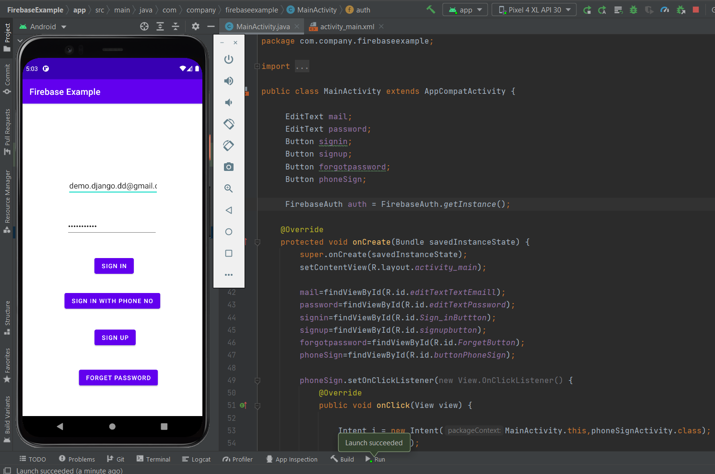

1. **Implement Local Notification project.**

**Activity_main.xml**

<?xml version="1.0" encoding="utf-8"?>

<androidx.constraintlayout.widget.ConstraintLayout xmlns:android="http://schemas.android.com/apk/res/android"

xmlns:app="http://schemas.android.com/apk/res-auto"

xmlns:tools="http://schemas.android.com/tools"

android:layout_width="match_parent"

android:layout_height="match_parent"

tools:context=".MainActivity">

<Button

android:id="@+id/button"

android:layout_width="wrap_content"

android:layout_height="wrap_content"

android:text="Button"

android:textSize="24sp"

app:layout_constraintBottom_toBottomOf="parent"

app:layout_constraintEnd_toEndOf="parent"

app:layout_constraintHorizontal_bias="0.5"

app:layout_constraintStart_toStartOf="parent"

app:layout_constraintTop_toTopOf="parent" />

</androidx.constraintlayout.widget.ConstraintLayout>

**MainActivity.java**

package com.company.localnotification;

import …

public class MainActivity extends AppCompatActivity {

Button button;

public final String CHANNEL_ID= "1";

int counter = 0;

@Override

protected void onCreate(Bundle savedInstanceState) {

super.onCreate(savedInstanceState);

setContentView(R.layout.activity_main);

button = findViewById(R.id.button);

button.setOnClickListener(new View.OnClickListener() {

@Override

public void onClick(View view) {

counter++;

button.setText(""+ counter);

if(counter == 5)

{

startNotification();

}

}

});

}

@RequiresApi(api = Build.VERSION_CODES.O)

public void startNotification()

{

Intent i = new Intent(this,MainActivity.class);

PendingIntent pendingIntent = PendingIntent.getActivity(this,0,i,0);

Intent actionIntent = new Intent(this,recivers.class);

actionIntent.putExtra("toast","This is Notification Message");

PendingIntent actionPending = PendingIntent.getBroadcast(this,0,actionIntent,0);

Notification.Action action = new Notification.Action.Builder(Icon.createWithResource(this,

R.drawable.ic_add_alert_24),"Toast Message",actionPending).build();

Intent dismissIntent = new Intent(this,reciversDismiss.class);

PendingIntent dismissPending = PendingIntent.getBroadcast(this,0,dismissIntent,0);

Notification.Action dismissAction = new Notification.Action.Builder(Icon.createWithResource(this,

R.drawable.ic_add_alert_24),"Dismiss",dismissPending).build();

NotificationChannel channel = new NotificationChannel(CHANNEL_ID,"1"

, NotificationManager.IMPORTANCE_DEFAULT);

NotificationManager manager = (NotificationManager)getSystemService(NOTIFICATION_SERVICE);

manager.createNotificationChannel(channel);

Bitmap icon = BitmapFactory.decodeResource(getResources(),R.drawable.abc);

// String text = getResources().getString(R.string.big_text);

Notification.Builder builder = new Notification.Builder(MainActivity.this,CHANNEL_ID);

builder.setSmallIcon(R.drawable.ic_add_alert_24)

.setContentTitle("Title")

.setContentText("Notification Text")

.setContentIntent(pendingIntent)

.setAutoCancel(true)

.addAction(action)

.addAction(dismissAction)

.setColor(Color.BLUE)

.setLargeIcon(icon)

.setStyle(new Notification.BigPictureStyle().bigPicture(icon));

NotificationManagerCompat compat = NotificationManagerCompat.from(MainActivity.this);

compat.notify(1,builder.build());

}

}

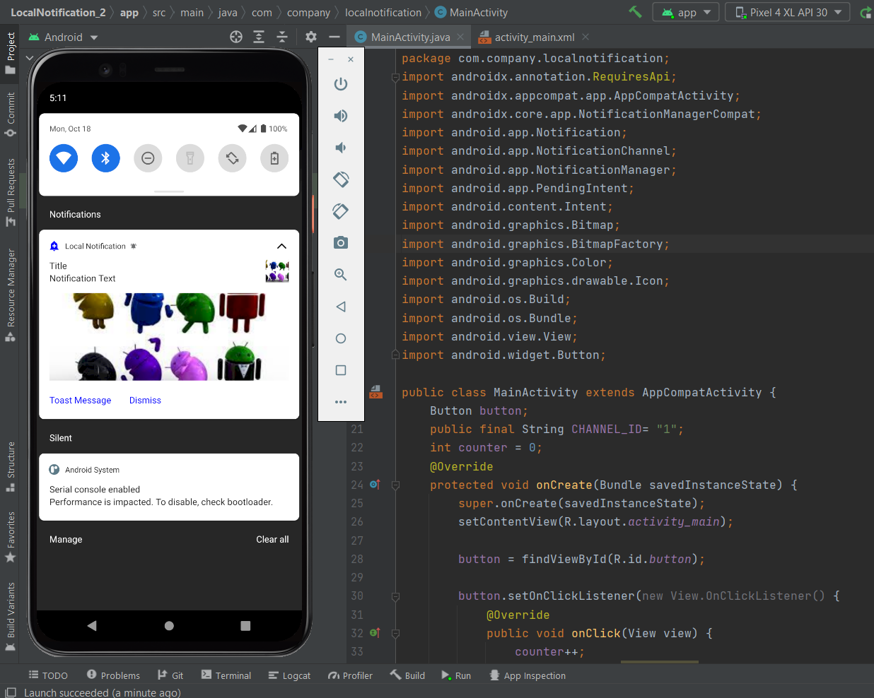

1. **Implement web view project.**

**MainActivity.java**

package com.example.webview;

import androidx.appcompat.app.AppCompatActivity;

import android.os.Bundle;

import android.webkit.WebView;

import android.webkit.WebViewClient;

public class MainActivity extends AppCompatActivity {

WebView webView;

@Override

protected void onCreate(Bundle savedInstanceState) {

super.onCreate(savedInstanceState);

setContentView(R.layout.activity_main);

webView = findViewById(R.id.web);

webView.setWebViewClient(new WebViewClient());

webView.loadUrl("https://www.google.com/");

}

@Override

public void onBackPressed() {

if(webView.canGoBack())

{

webView.goBack();

}

else {

super.onBackPressed();

}

}

}

**Activity_main.xml**

<?xml version="1.0" encoding="utf-8"?>

<androidx.constraintlayout.widget.ConstraintLayout xmlns:android="http://schemas.android.com/apk/res/android"

xmlns:app="http://schemas.android.com/apk/res-auto"

xmlns:tools="http://schemas.android.com/tools"

android:layout_width="match_parent"

android:layout_height="match_parent"

tools:context=".MainActivity">

<WebView

android:id="@+id/web"

android:layout_width="match_parent"

android:layout_height="match_parent" />

</androidx.constraintlayout.widget.ConstraintLayout>

